

UNIVERSITY OF PETROLEUM AND ENERGY STUDIES
DEHRADUN

CYBER THREAT INTELLIGENCE

LAB 6 Report Malicious Artifacts

MTECH-COMPUTER SCIENCE
ENGINEERING
CYBER SECURITY AND FORENSICS

Name: Jigesh Sheoran
SAP ID: 590025428

Objective — Learn to report malicious artifacts to CTI community portals.
Task 1 : AbuseIPDB
Goal: Report abusive IP addresses involved in hacking, phishing, or other malicious behaviours. Enter IP address and select a category to click and report that IP.
Step 1: Login to AbuseIPDB portal with free account to report a malicious IP address (like the source IP address of an attacker on https://www.abuseipdb.com/report
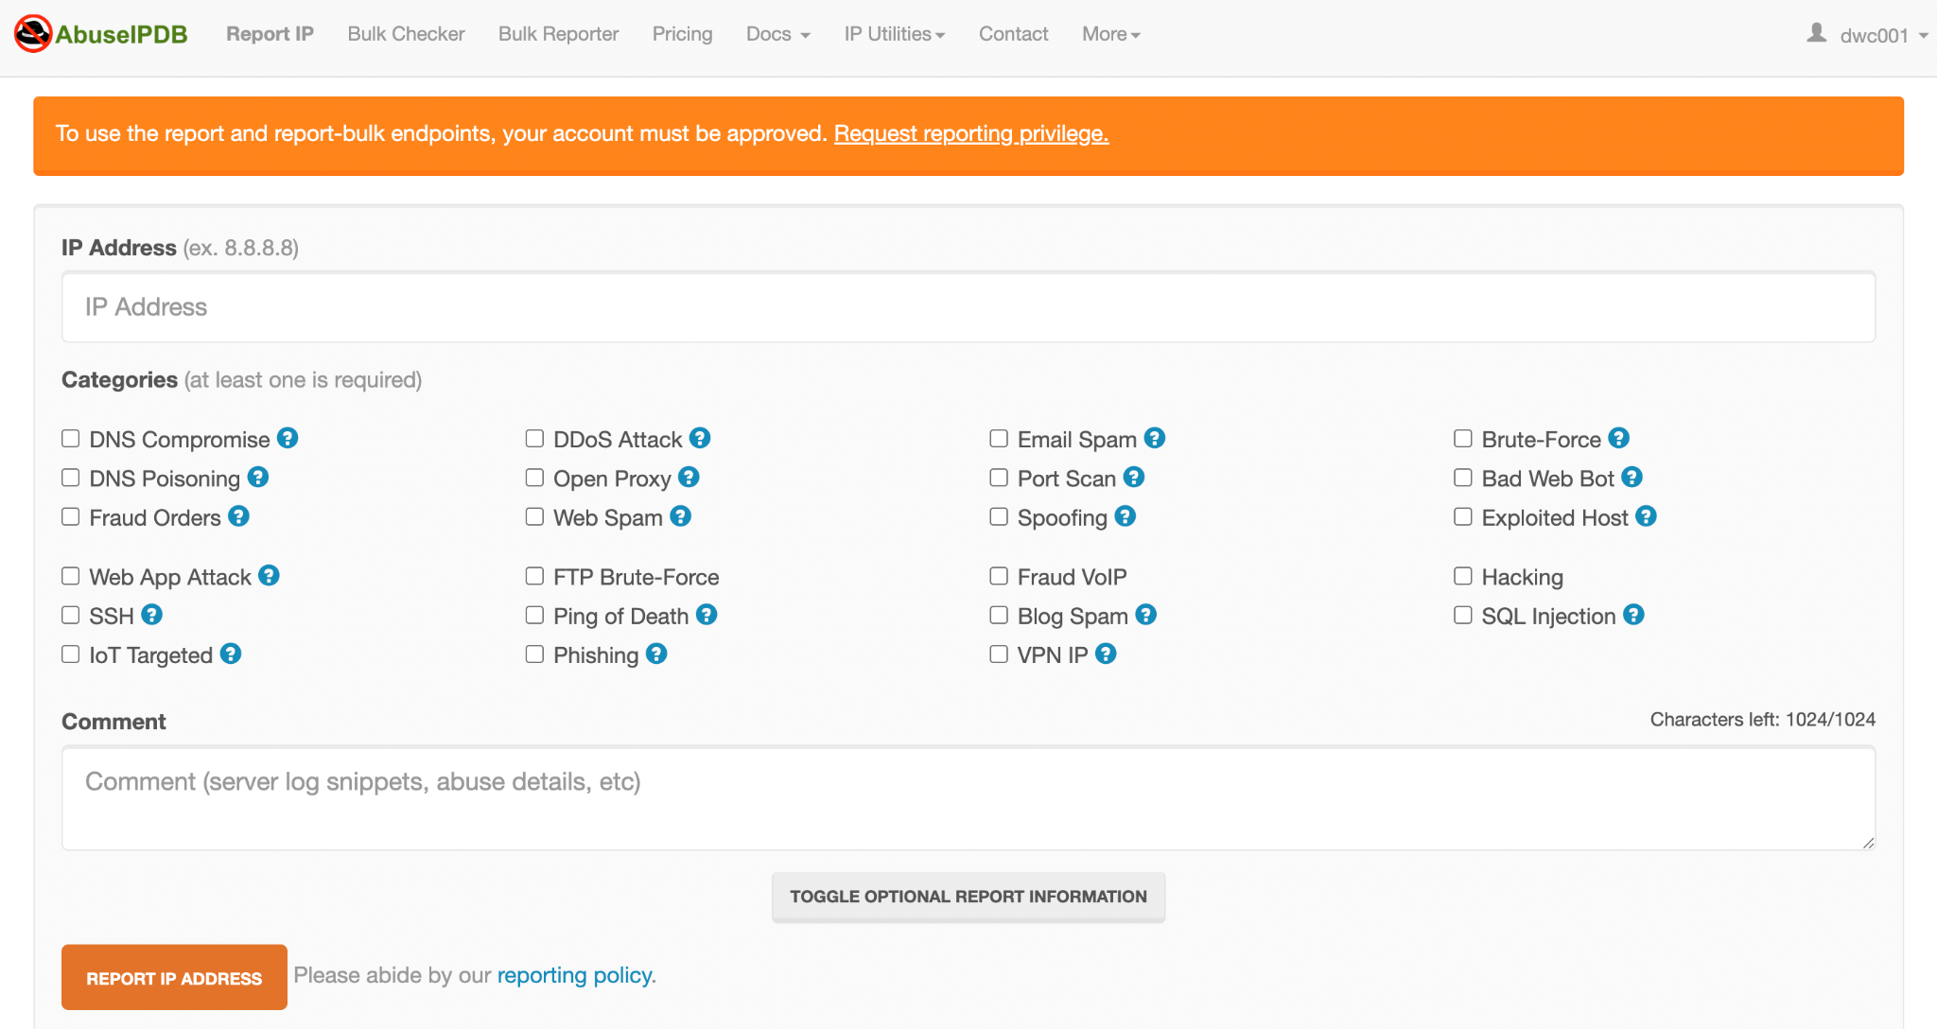
Sign In to you AbuseIPDB account using your credentials.
Step 2: Open the IP address list for Spam IP Addresses from Github https://github.com/duggytuxy/malicious_ip_addresses/blob/main/botnets_zombies_scanner_spam_ips.txt and copy an IP address to validate, chose options as required.
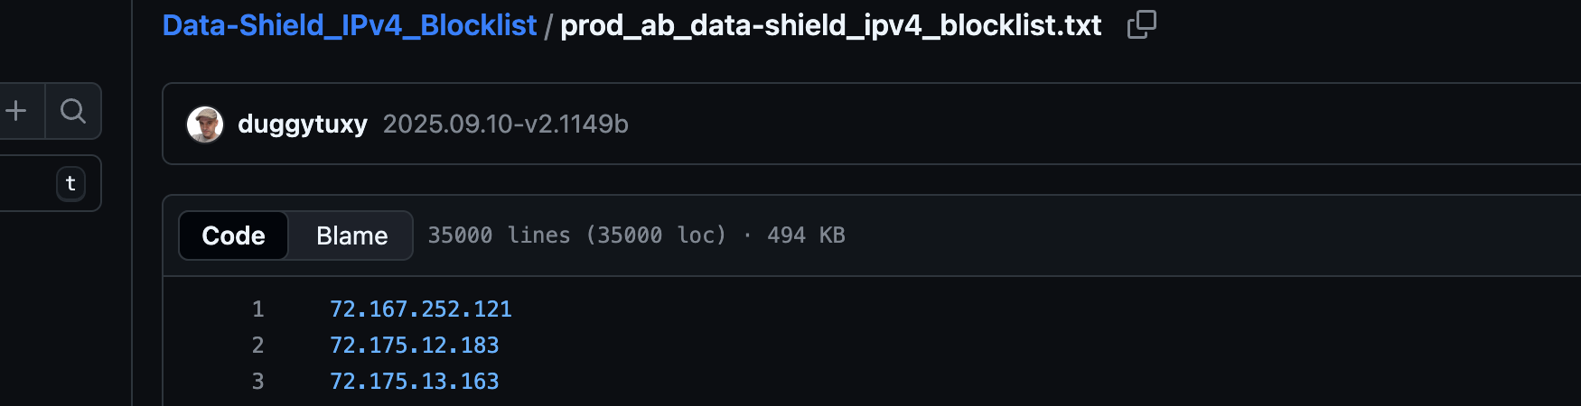

to validate the IP (imp. before reporting) Use multiple sources to confirm malicious activity:
- VirusTotal / AbuseIPDB history — search the IP first.
- WHOIS / RDAP — check owner, ASN, registrar.
- Passive DNS / Historical DNS — find domains resolving to it.
- Shodan / Censys — open ports, services, banners (are they hosting legitimate services?).
- Threat Feeds / Blocklists — check if it’s on public blocklists.

Target IP : 72.167.252.121
Search the IP behaviour first via virustotal.com
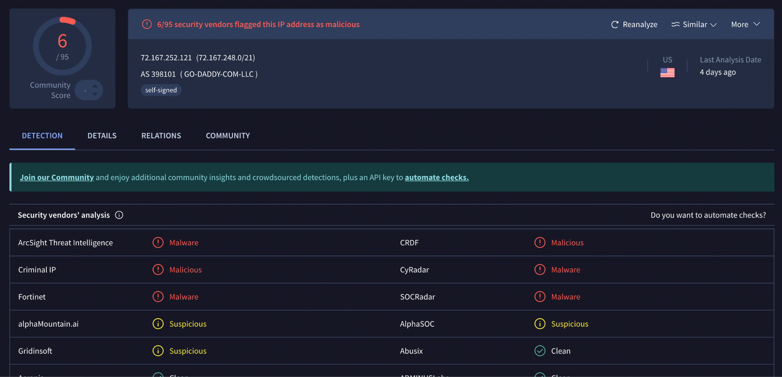
Finding from VirusTotal.com
- IP Address: 72.167.252.121
- ASN: 398101 — GO-DADDY-COM-LLC
Location: United States (Tempe, AZ — GoDaddy HQ)
- VT Community Score: 6/95 vendors flagged as malicious (suspicious, but not fully blacklisted).
- Certificate Info: Self-signed TLS cert (gdreseller.local) → very abnormal for a hosting provider → often tied to phishing or fake reseller setups.
- WHOIS / Abuse Contact: abuse@godaddy.com
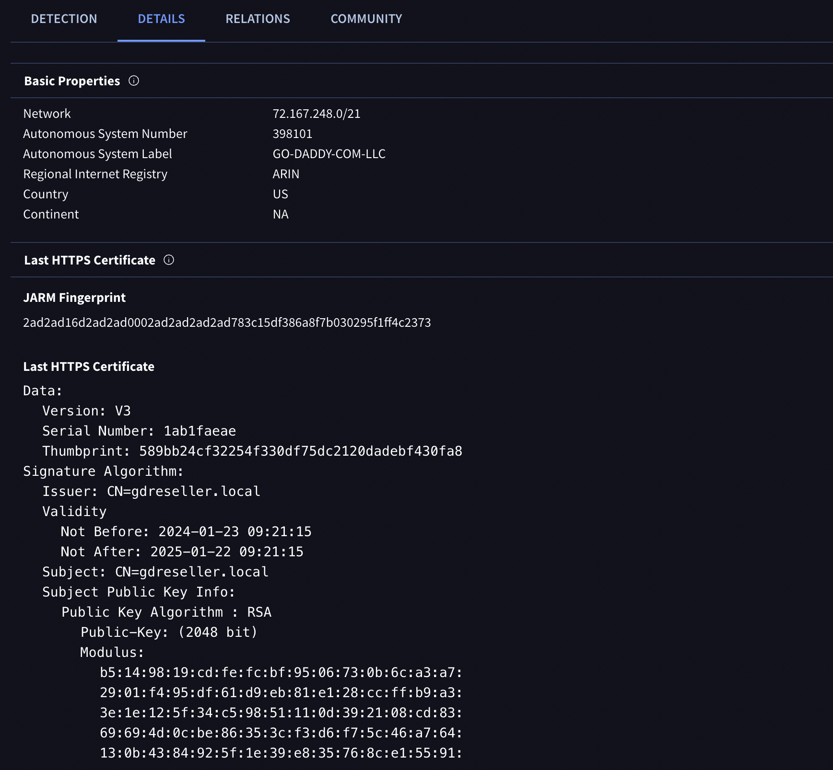

Search the IP behaviour first via shodan.io
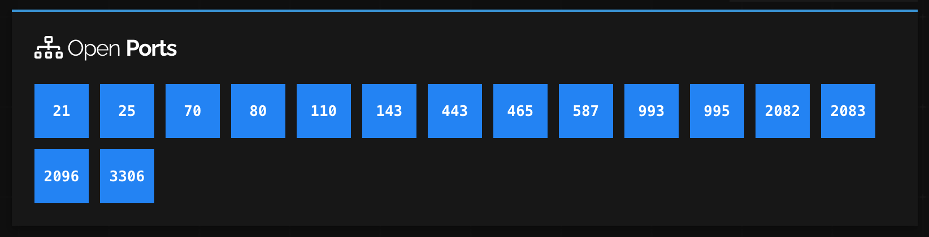
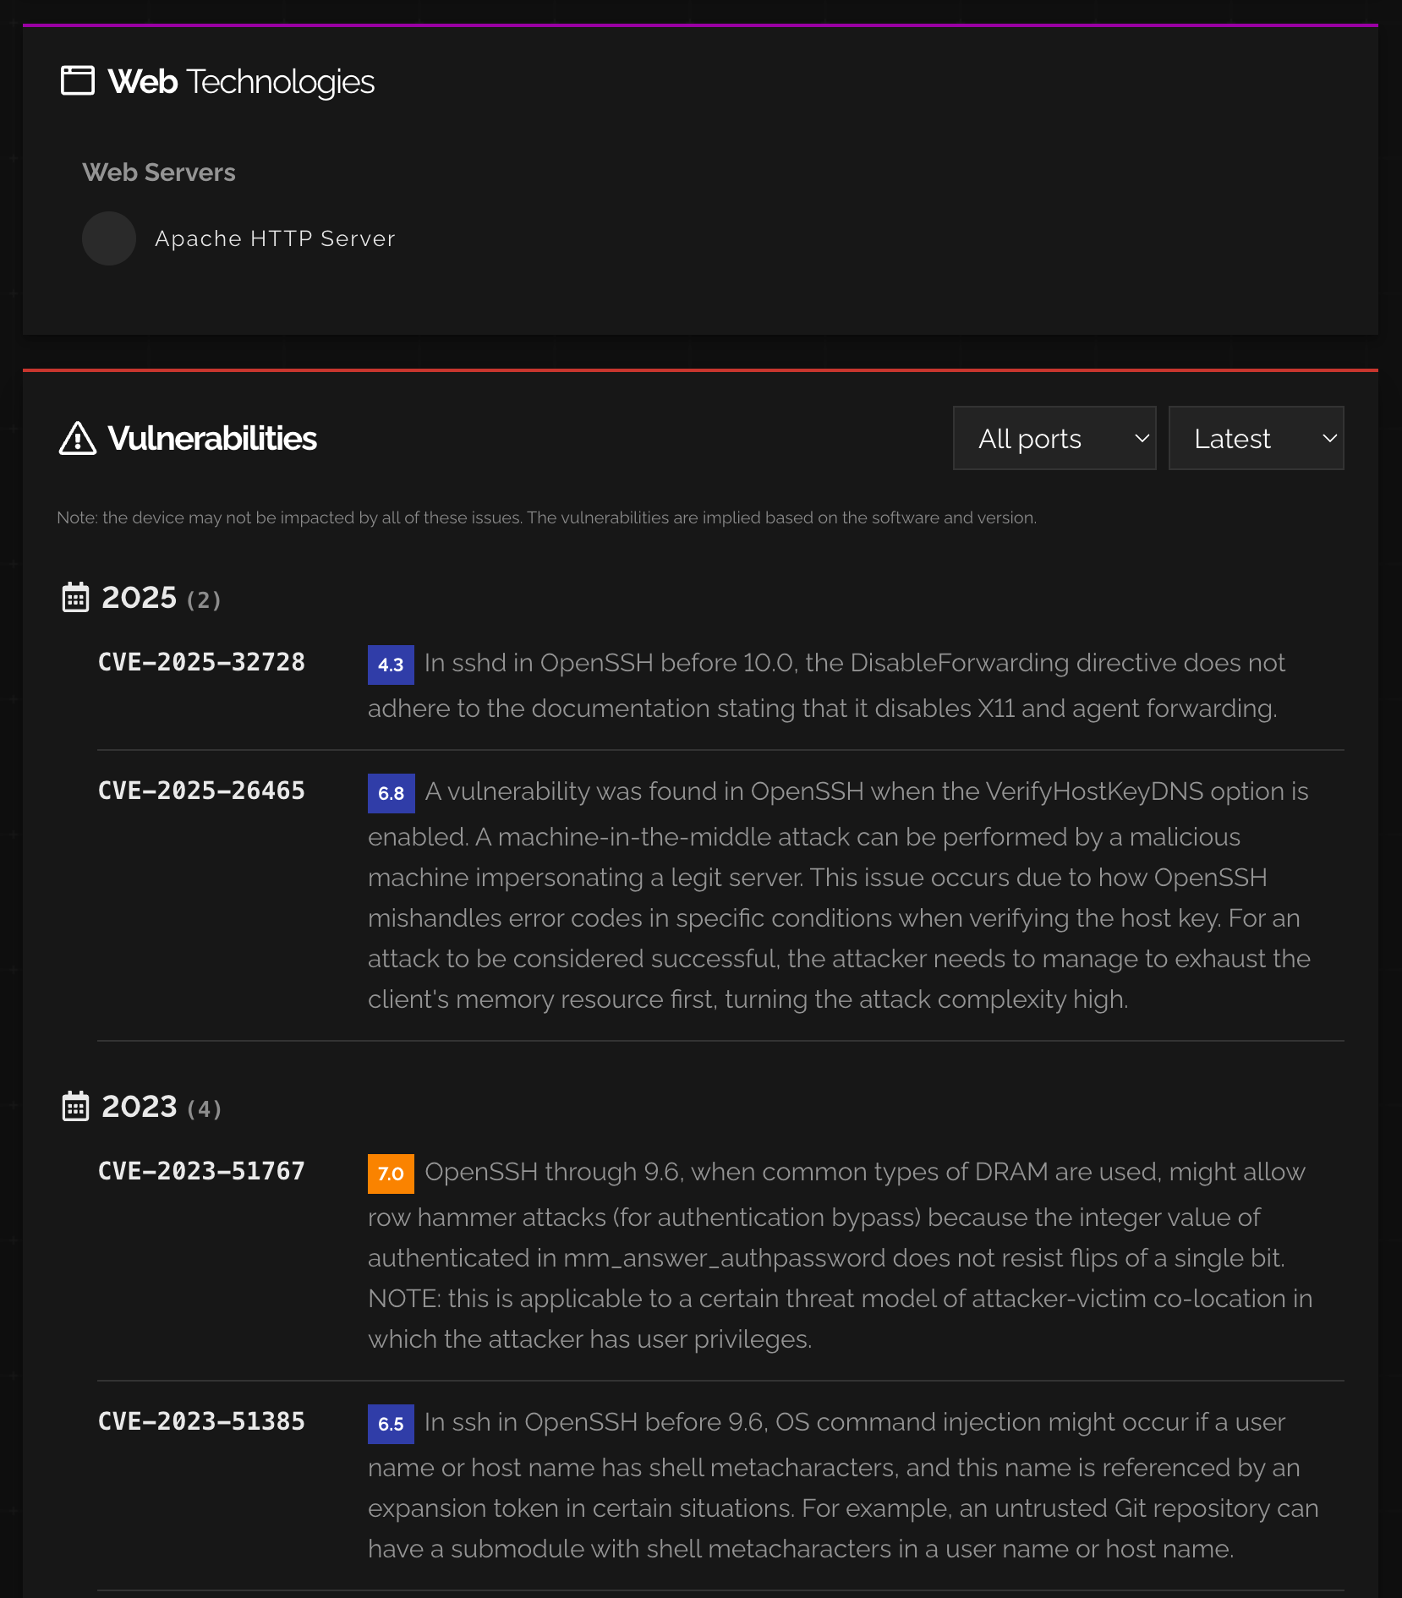

Finding from shoada.io
- Open ports: 21, 25, 70, 80, 110, 143, 443, 465, 587, 993, 995, 2082, 2083, 2096, 3306.
- Full web/mail/database/control panel exposure (large attack surface).
- Vulnerabilities (based on banner inference):
  - CVE-2023-38408 (CVSS 9.8) – ssh-agent RCE.
  - CVE-2020-15778 – scp command injection.
  - CVE-2023-48795 (Terrapin attack) – SSH integrity bypass.
CVE-2025-32728 / CVE-2025-26465 – new OpenSSH forwarding/MITM issues.
- Suggests outdated OpenSSH service and potential compromise.
Finally, reporting this conclusion on Abuse IPDB.
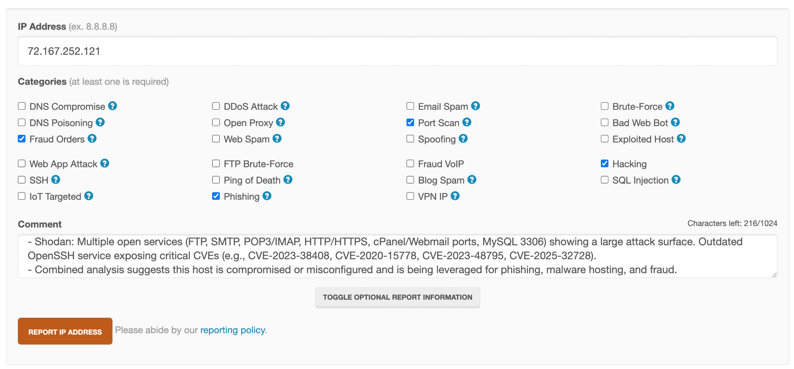

Task 2 : URLhaus :
This is a project by abuse.ch that focuses on sharing malicious URLs used for malware distribution.

Step 1: Create a free account to report on https://urlhaus.abuse.ch/browse/ and enter an IP or Domain to report.

URLhaus Dashboard:
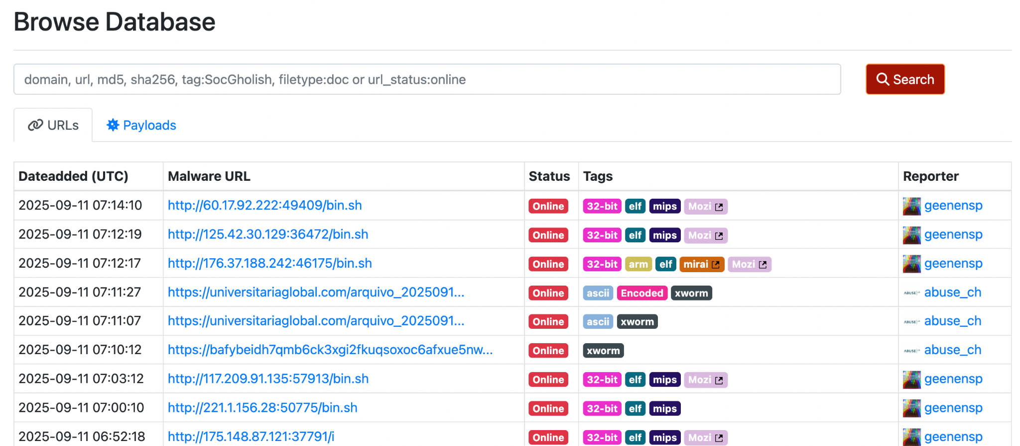

After you create an account and login using your credential you will see Manual / Import setting for submitting a new report.

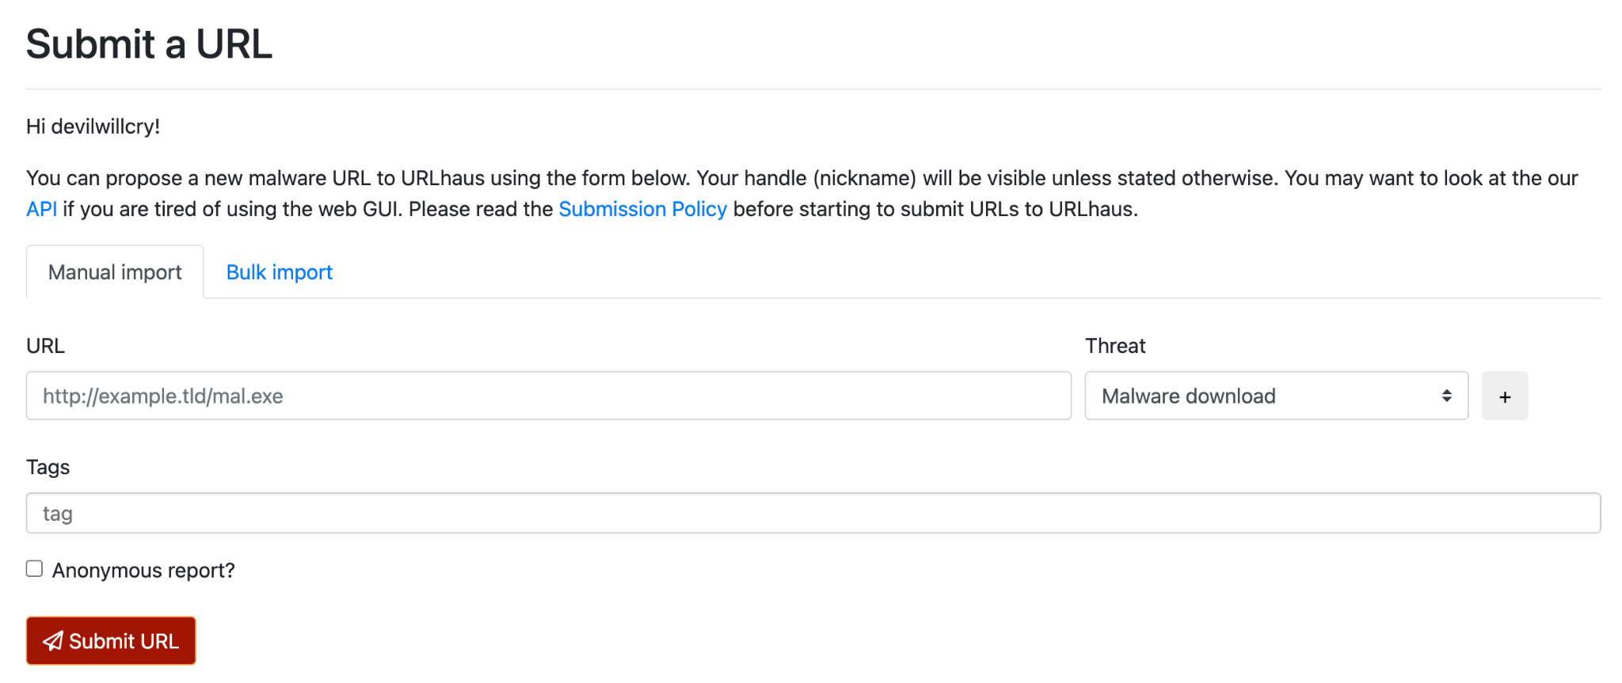

For reporting we will use the same IP we analyzed in Task 1.
Target IP : 72.167.252.121

Firstly we will search for this IP in URLhaus DB like this http://72.167.252.121
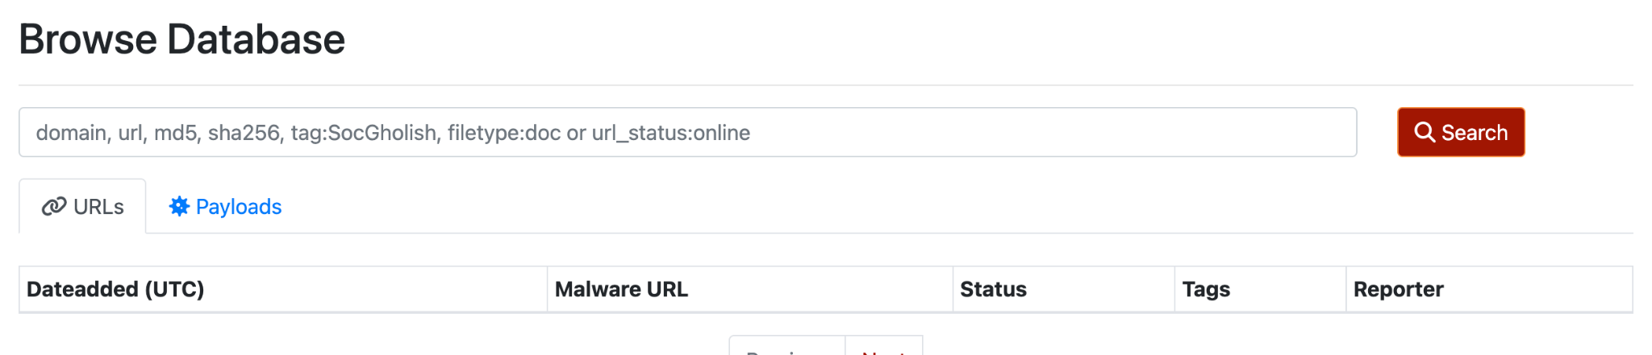

As we can see from the above figure that the query returned null value which means that the following IP is not present in URLhaus database.
So, we will submit the malicious IP address in question.

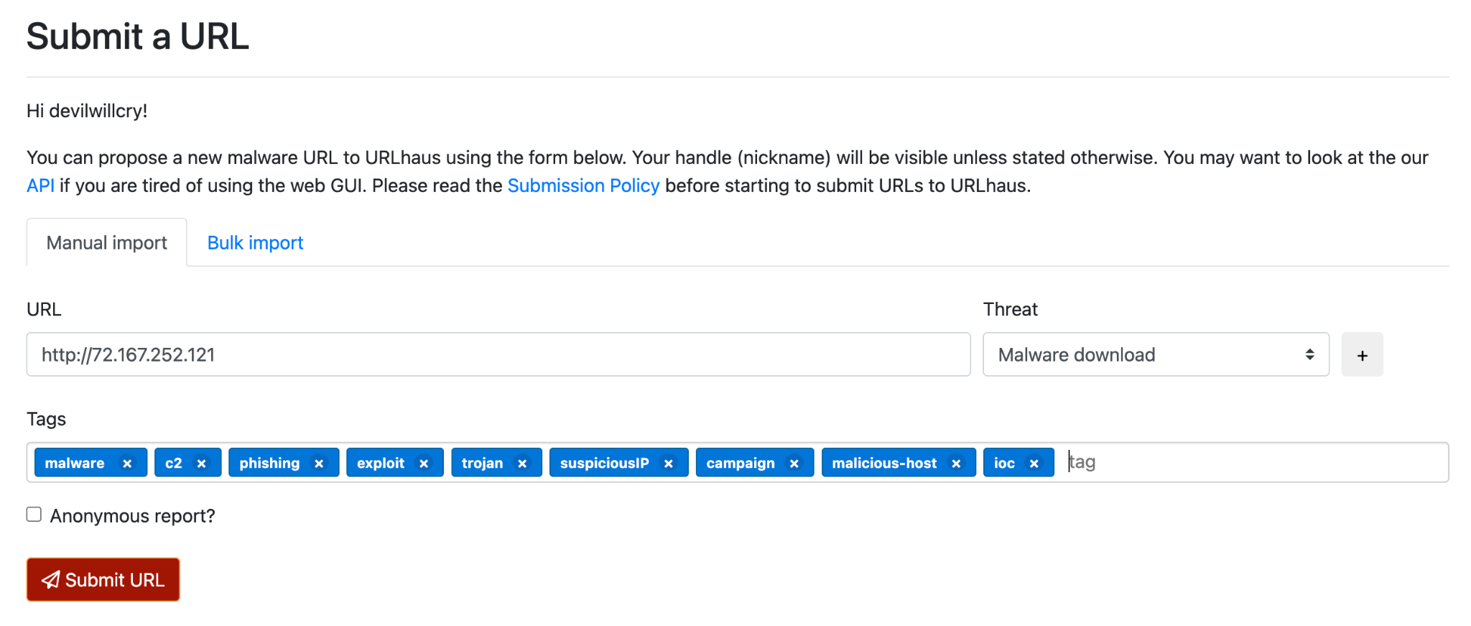

Here is the submitted query for the IP in question.

Task 3 : MISP (Malware Information Sharing Platform)

This is a free, open-source platform designed for sharing threat intelligence. It allows you to submit IOCs along with contextual information like the type of threat, affected systems, and mitigation techniques.

Step 1: MISP on Docker can be setup using https://github.com/misp/misp-docker
Installing the docker image using git clone
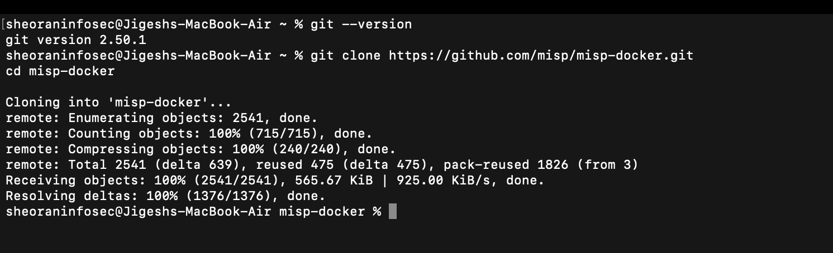

Task 4 : PhishTank

This is a community-driven platform for reporting and tracking phishing websites. It's a valuable resource for identifying phishing attempts and sharing them with the security community.

Step 1: Open https://phishtank.org/ and submit a domain to validate if it is a phishing site or not.
PhishTank Dashboard:
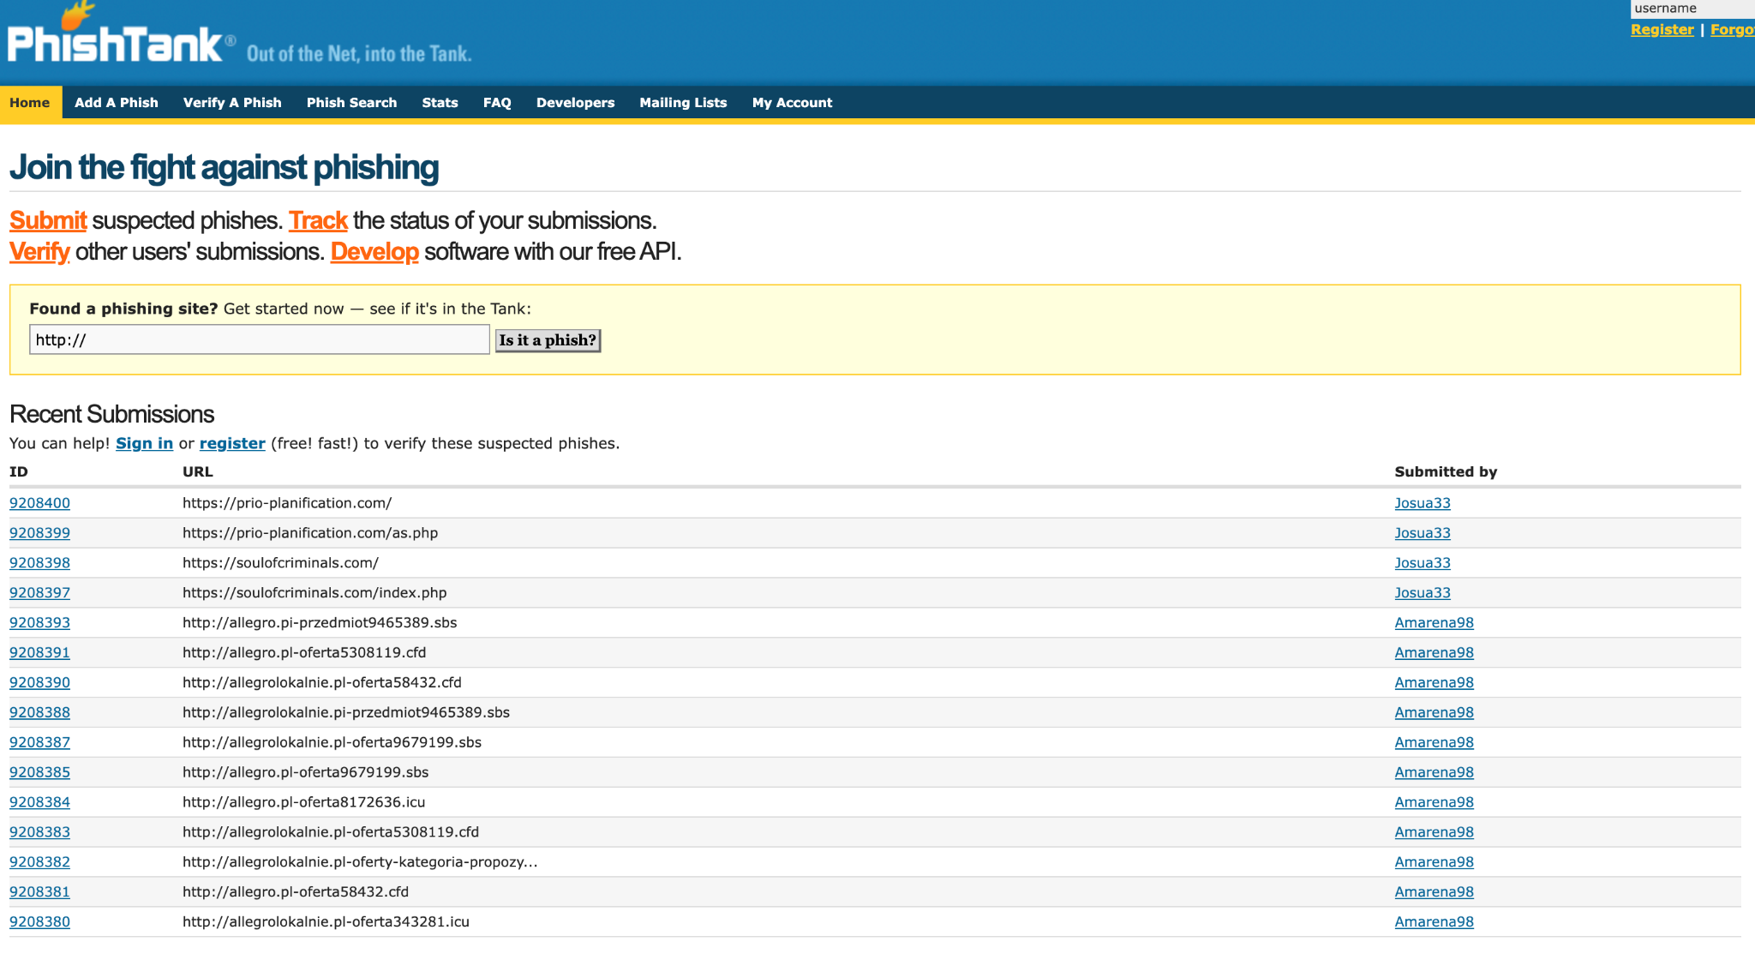
Target URL : “https://www.yaheaooc.com/” ( Yahoo Japan )

Firstly, we will continue with our favorite practice i.e searching everything potentially malicious on virustotal.com

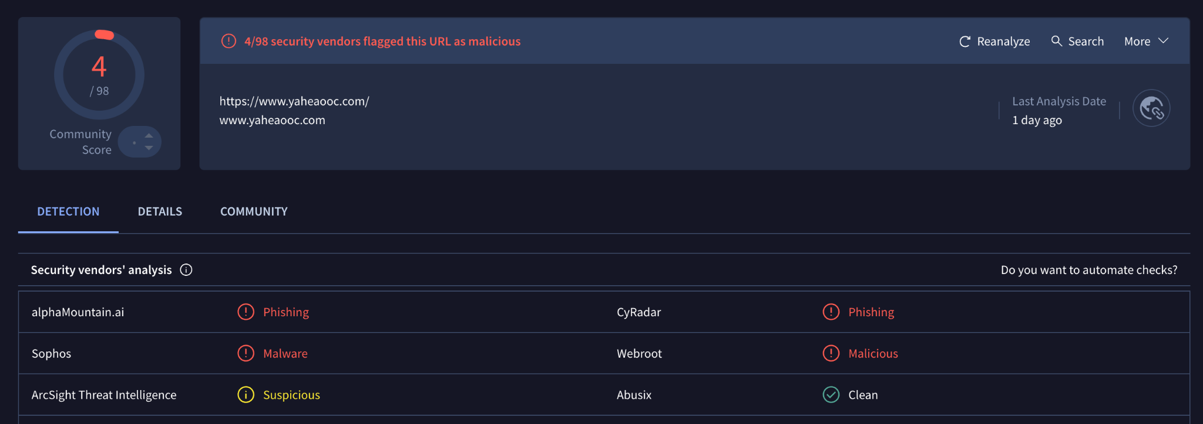

VirusTotal results:
- Community Score 4/98
- 4 vendors marked it as Malicious/phishing and one marked it as suspicious which means that this URL has shown unusual behaviour.
- alphaMountain.ai –Phishing
- Sophos – spyware and malware
- Webroot – Phishing and other frauds

This URL has already been submitted to phishtank.org , but the submission is online for some reason.
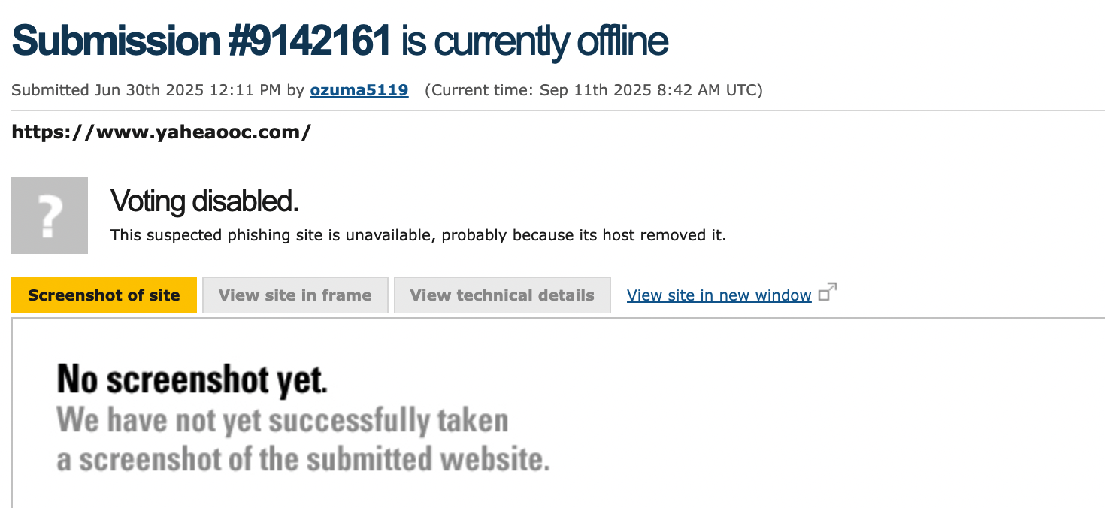

Note: New user registration is also temporarily closed.

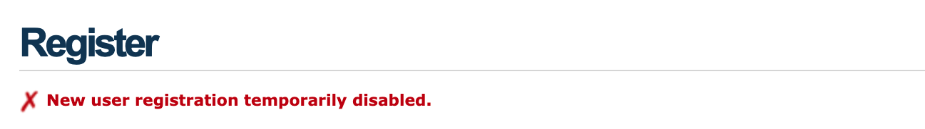

Task 5 : BlockList.de
This volunteer-run service allows reporting various cyberattacks, including those identified through IOCs. They focus on informing relevant parties like service providers to act.

Step 1: Search for an IP using https://www.blocklist.de/en/search.html to validate it is malicious.
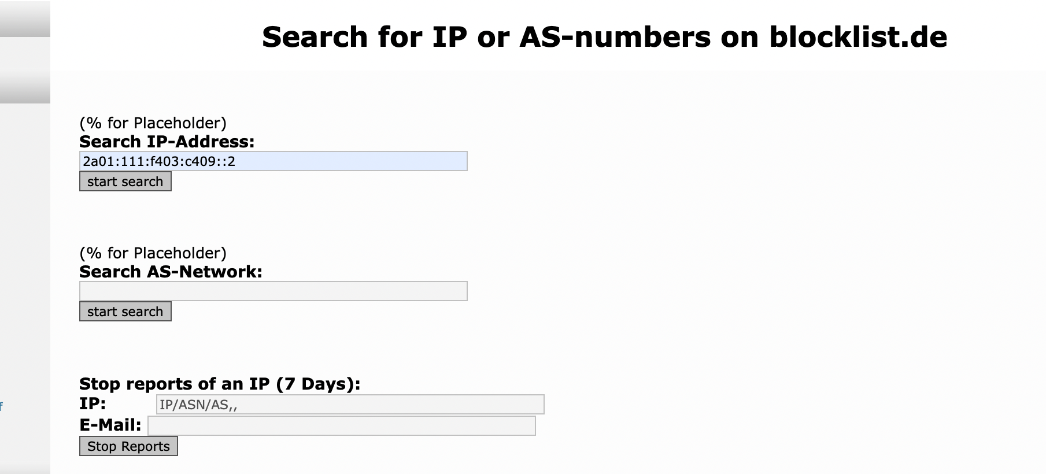

Step 2: IoCs can also be obtained from Github link at https://github.com/hslatman/awesome-threat-intelligence?tab=readme-ov-file#tools

After trying almost 25 different IPs from different sources i was not able to get a positive result from blocklist.de , all the queries resulted with NULL values.
Sources Tried:
- https://github.com/bitwire-it/ipblocklist/blob/main/ip-list.txt
- https://github.com/hslatman/awesome-threat-intelligence
- https://threatview.io/
- abuse.ch

Finally at the last attempt i got a positive result by using this Source : “https://github.com/stamparm/ipsum”
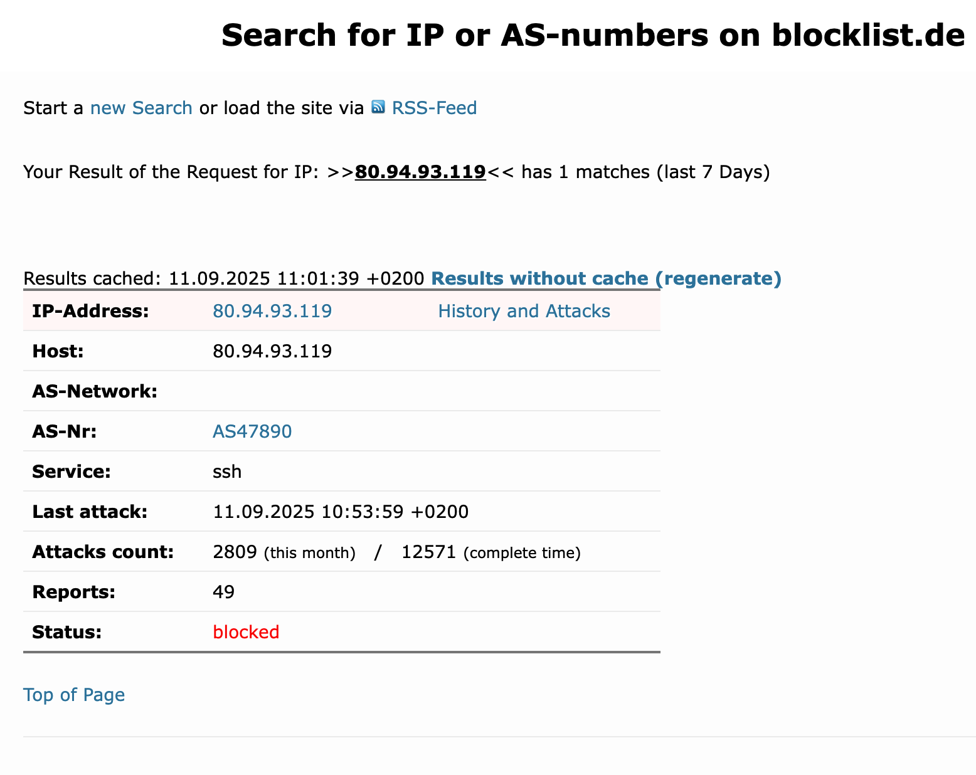

Learning:
- Malicious IP identified
- Attack vector – The service targeted is SSH, which indicates brute-force login attempts or unauthorized access attempts.
- Recency – The last attack was recorded on 11.09.2025 10:53:59 +0200, i.e., within the last 7 days → confirming it is an active threat.
- Attack frequency – 2809 attacks this month
- 12,571 attacks total - shows the IP has been persistently abusive, not just a one-off incident.
- Community reporting – 49 reports
- Status – Currently marked as blocked

Step 3: Study the trend using Statistical Graph from
https://www.blocklist.de/en/statisticsgraph.html
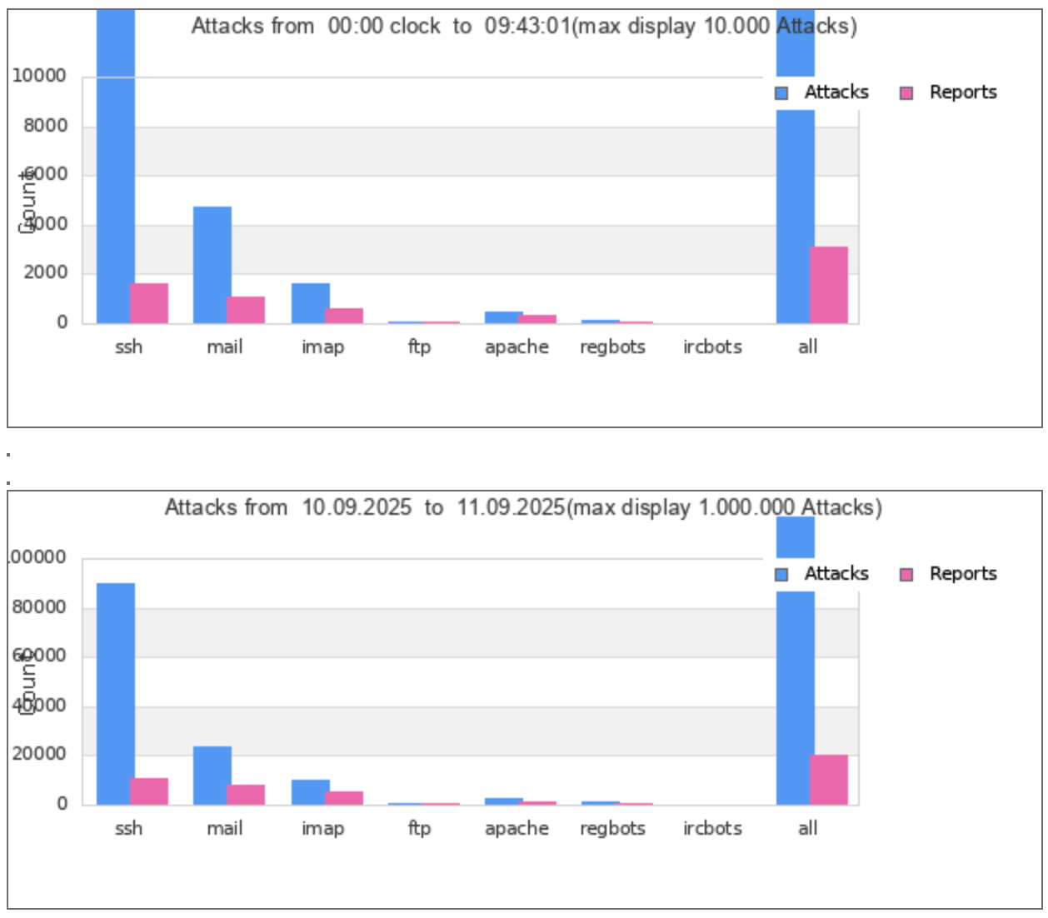
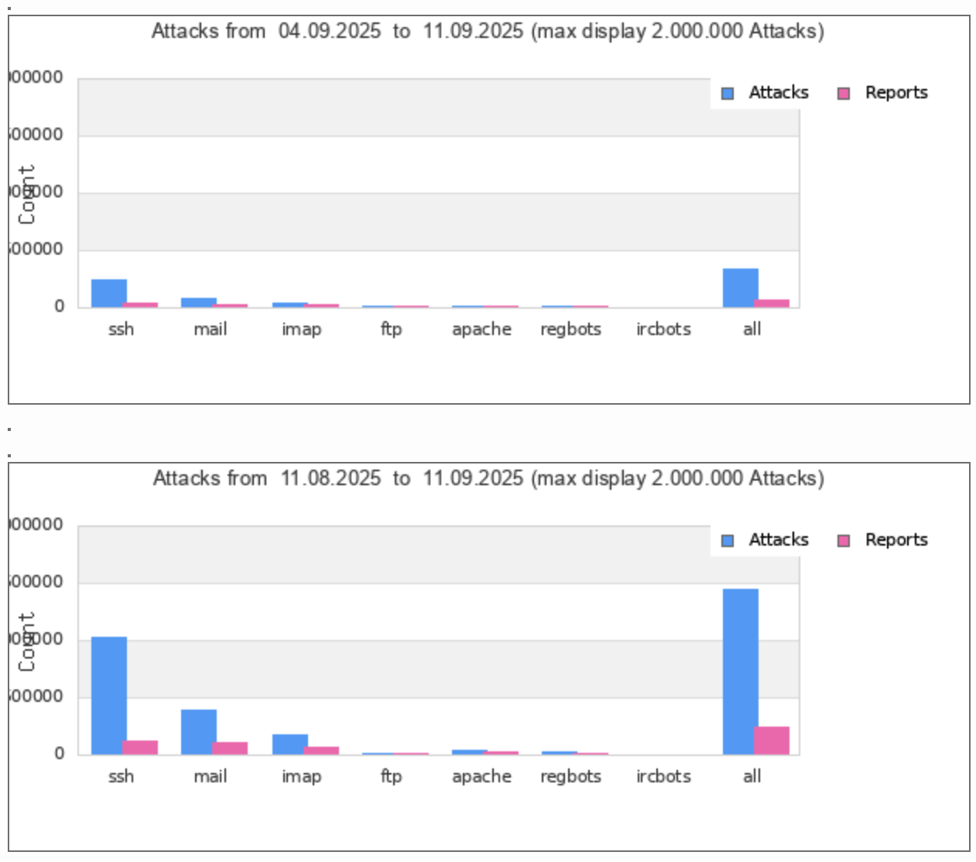

Observation / Learning :
- SSH is the top target
- Across all time ranges (hours, days, weeks), SSH has the highest number of attacks and reports.
- This confirms that SSH brute-force attacks are the most common automated attack type seen on the internet.

- Mail and IMAP are also targeted
After SSH, mail servers (SMTP, IMAP) show significant attack activity.
- Indicates attackers also try to compromise email infrastructure (spamming, phishing relays, credential harvesting).

- Other services (FTP, Apache, Regbots, IRCbots)
- Much lower attack volume compared to SSH/Mail.
- Still worth noting: occasional scanning or exploitation attempts.
- Blue (attacks) far outnumber pink (reports).
- From short time windows (hours) to longer (weeks/months), SSH remains consistently dominant.
- Attack counts scale up dramatically in longer time frames → persistent, ongoing activity rather than isolated bursts.

----------------------------------------------------END------------------------------------------------------

